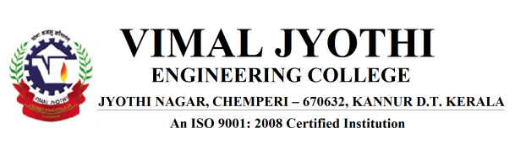
EVENT PROPOSAL FORM
1 | Event type and  Name | Webinar on Opportunities in Aerospace industries
2 | Date and time | 11-06-2020; 4:00 PM-5:00 PM
3 | Participants/audience | S8 ME students (2016-20)
4 | Venue | Online Plat form Google Meet  meet.google.com/bpa-ydpz-fao
5 | Objectives | Curricular Gap Bridging Event
6 | Expected outcomes | Students will be able to understand about engineering industry and the opportunites in industry.
7 | Connected  POs/PSOs | PO6,PO7,PO12
8 | Justification for POs/PSO’s | The session will impart a line knowledge on industrial engineering and what the industry is looking for.
9 | Resource requirements | Mr. SATHEESH PALAKKEEL,ASSOCIATE GENERAL MANGER, AEROSPACE NAD DEFENC ,HAL TECHNOLOGIES LTD, BANGALORE.Online Plat form Google Meet
10 | Any other Relevant  Information | Nil
11 | Responsible  Persons | Coordinator: Mr. RAMESHAN.K.P,Associate Professor, ME
12 | Department | Mechanical Engineering

Proposal prepared by Recommended by
Rameshan.K.P (AP, ME) Cdr. Raju K K (Retd.) HOD ME

