Sustainable Development Goals (SDGs)

The Sustainable Development Goals (SDGs) are a set of 17 global goals set by the United Nations to end poverty, protect the planet, and ensure peace and prosperity for all.
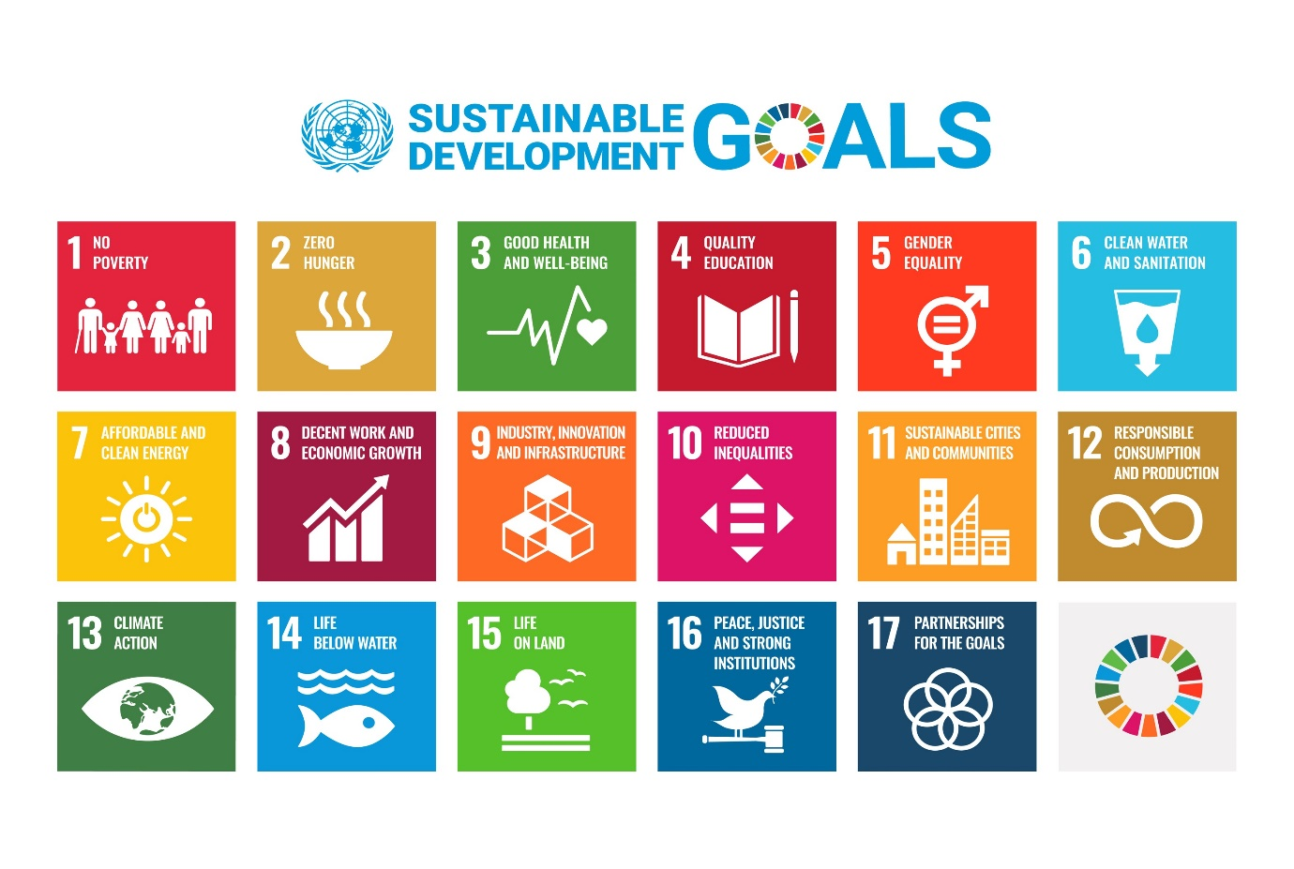

Vimal Jyothi Engineering College has implemented SDGs by incorporating its goals into the curriculum by incorporating courses and projects that address the SDGs.

The college has also implemented sustainable practices in its operations, such as reducing waste and energy usage, promoting sustainable transportation, and ensuring fair and equal treatment of all members of the college community. The college also collaborate with local organizations and governments to address sustainable development challenges in the surrounding community.

